91.460-530.203 Cyber Crime Investigation
Assignment 3
(10 points)

Instructions:
- Note: Blue text points to a web link. Ctrl + Click to follow link.
- This is an individual assignment.
- Answers to all questions including hands-on project with screen shots must be put into ONE document. That is, every time, each student can only submit one report document, answering all questions of this assignment.
- Students must put answers following each question in this assignment. The instructor will not grade a report with only answers in it and the student gets zero for such an assignment. An assignment report must include original questions.
- Students MUST submit the finished assignment in either Microsoft Word or pdf format to Blackboard. The doc must be submitted as a standalone file and cannot be tarred or zipped into a container.
- All Hands-on exercise that operates some software is required with screenshots of the actions to prove that the project is performed. The required screenshots must be put into the doc at appropriate place with explanation.
- Refer to Print screen on how to take a screenshot. Pressing the Alt key in combination with PrtSc will capture the currently selected window.

Questions:

Hands-on Project 3-2 (2 points). (Note: this project is slightly changed and different from the one in the textbook)

Minimal requirements: Screenshot for Step 5
In this project, you make a ProDiscover image file of the data on a USB or FireWire drive, follow these steps:
- Turn on your acquisition workstation, if necessary.
- Connect the suspect drive to your acquisition workstation (Use write protection in real cases even if it is not required here).
- Start ProDiscover Basic. Follow the steps in this chapter for making a raw format acquisition in ProDiscover, making sure you click UNIX style dd in the Image Format drop- down list box. Then click OK in the Capture Image dialog box.
- When the acquisition is finished, exit ProDiscover. Dismount the USB or FireWire device, remove the suspect drive, and secure it as evidence.
- Open the image file using ProDiscover and show all files on the USB drive are over there.
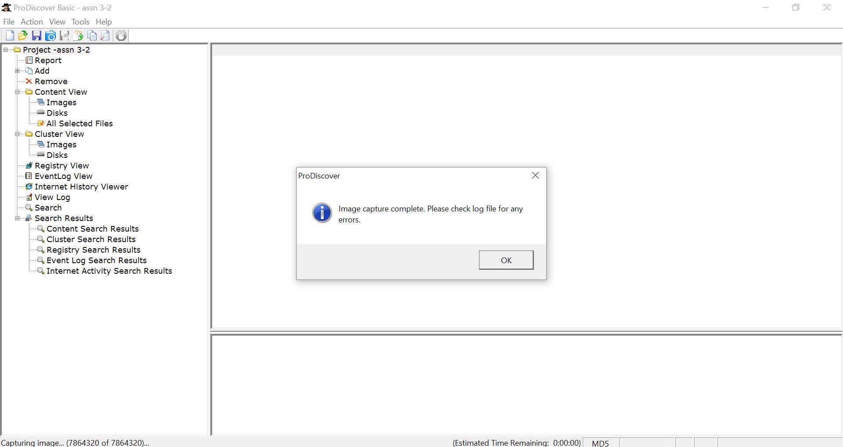
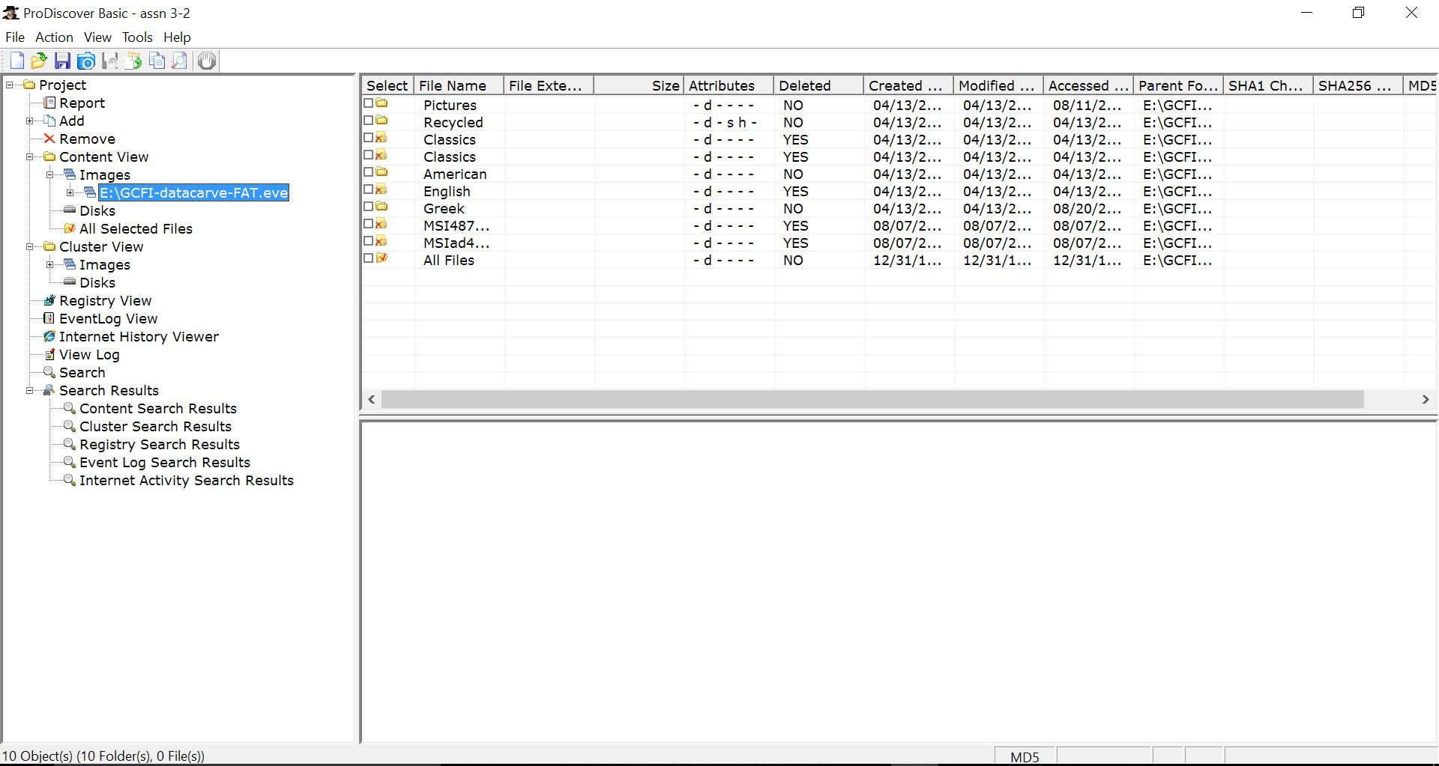

Hands-on Project 5-1. (2 points)

Minimal requirements: Finish Step 11
In this project, you compare two files created in Microsoft Office to determine whether the files are different at the hexadecimal level. Keep a log of what you find. Follow these steps:

1. Start Word, and in a new document, type This is a test.
2. Save the file as Mywordnew.doc in your work folder, using Word 97-2003 Document (*.doc) as the file type. Exit Word.
3. Start Excel, and in a new workbook, enter a few random numbers. Save the file in your work folder as Myworkbook.xls, using Excel 97 - 2003 Workbook (*.xls) as the file type.
4. Exit Excel, and start WinHex (running it as an Administrator).
5. Click File, Open from the menu. In the Open dialog box, navigate to your
work folder and double-click Mywordnew.doc.
6. Notice the file hexadecimal header D0 CF 11 E0 Al Bl 1A El starting at offset 0. Click Edit, Copy All from the menu, and then click Editor Display.
7. Start Notepad, and in a new document, press Ctrl+V to paste the copied data. Leave this window open.
8. Click File, Open from the WinHex menu. In the Open dialog box, navigate to your work folder and double-click Myworkbook.xls.
9. Repeat Step 6.
10. Paste the data you just copied under the Word document header information you pasted previously.
11. In the Notepad window, add your observations about the two files’ header data. Save this file as C5Prj01.txt and turn it in to your instructor.
12. Exit WinHex.

Hands-on Project 6-2. (2 points).

Minimal requirements: Finish Step 8

In this project, you research and download a disk-cleaning and wiping tool and verify that it works. Make sure you aren’t on a production machine. Do an Internet search for disk-cleaning and wiping software, and download and install at least one tool. Then follow these steps:
      - Create a C6Prj02 folder on your USB or disk drive. Start the tool you just installed.
      - Select your USB drive. Following instructions in the software documentation, wipe the drive.
      - Start OSForensics, and start a new case. Type your name for the investigator’s name, type C6Prj02 for the case name, and enter your work folder as the case path. Create a subfolder called C6Prj02, and click OK.
      - Click the Add Device button. Click the Drive Letter option button, if necessary, and in the drop-down list box, click the drive letter for your USB drive. Click OK.
      - Click Start in the left pane, if necessary, and click the Deleted Files Search button on the left. (Note: This is another way to open the Deleted Files Search window.)
      - Click the Disk list arrow, and then click the USB drive in the list of options. Click the Search button. Because you’re searching for deleted files, you don’t need to enter a file string.
      - Double-click any file in the lower pane to open it.
      - If necessary, click the Hex/String Viewer tab (see Figure 6-8). It should show hexadecimal 0 values, which verifies that the disk wipe worked. Take a screenshot, and then exit OSForensics. Write a short report on the tool’s effectiveness, and turn it in to your instructor with the screenshot.
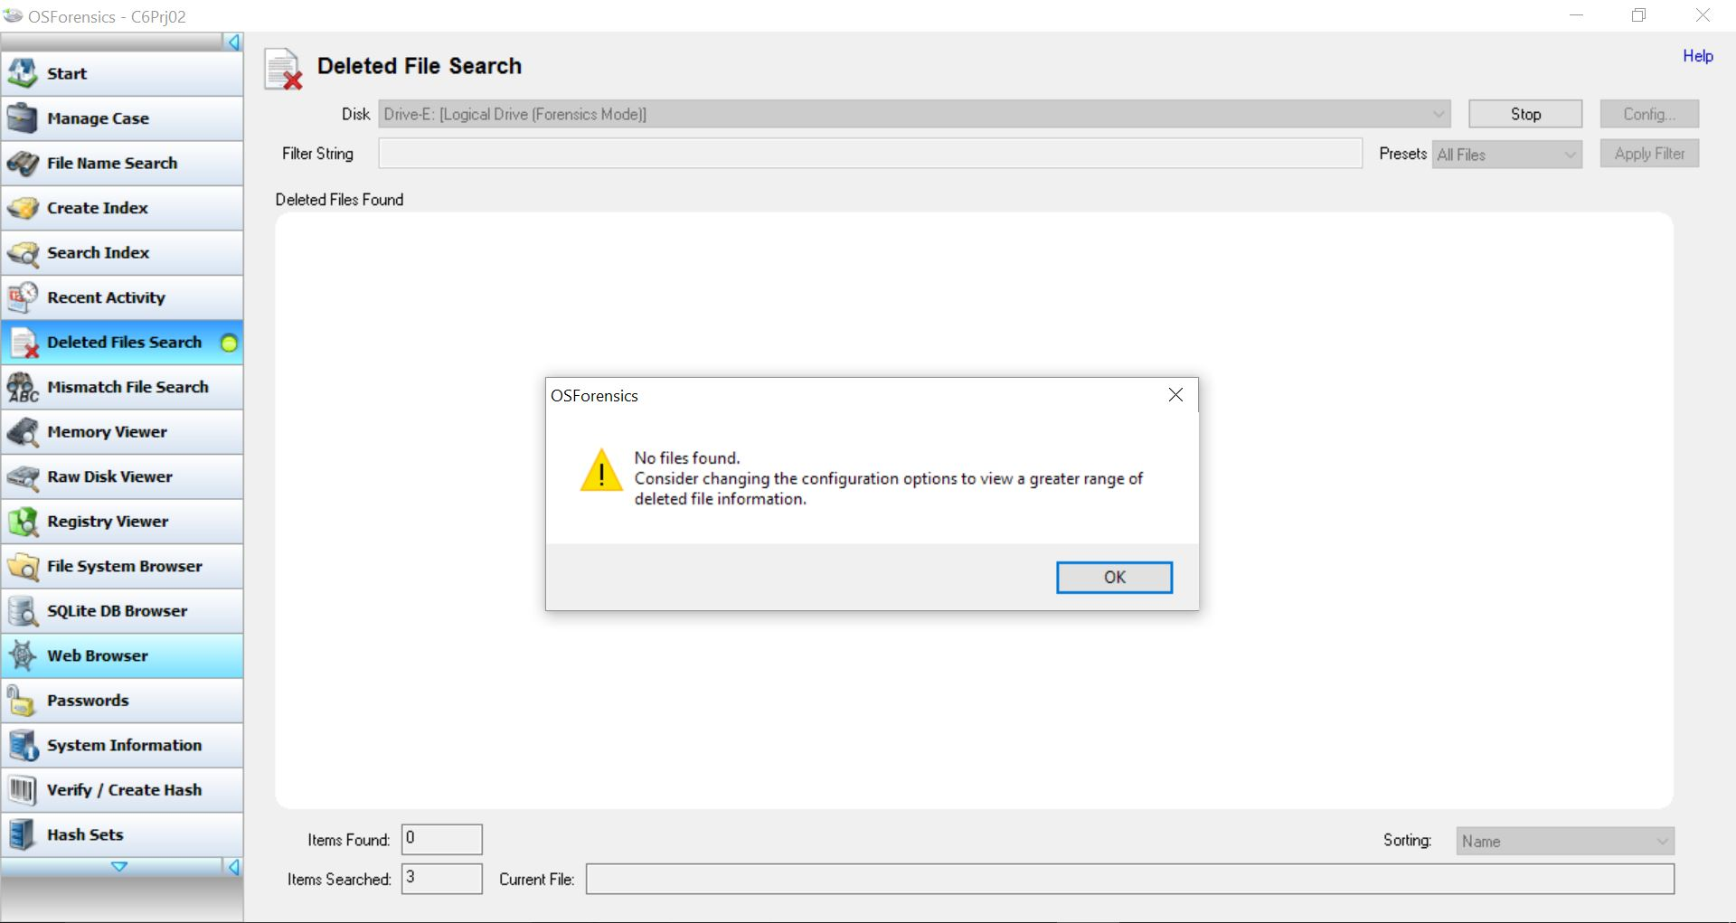
The tool which have used has deleted all the content in the USB device and it’s very effective. But, after I tried to search for the deleted content using OSForensic software, the above screenshot was found. From the project we did, we can know that both the software’s are very efficient. Disk Wipe software wiped the disc completely. We can easily track deleted files in OS forensics, this can be used to find the deleted files in systems for finding cyber criminals. And also checked with the Hex/String Viewer tab.

Hands-on Project 8-1. (2 points)

Minimal requirements: Turn in report in Step 5

In this project, you use ProDiscover Basic to locate and extract JPEG files with altered extensions. Some of these files are embedded in files with non- JPEG extensions. Find the C08frag. eve file in your work folder, and then follow these steps:
- Start ProDiscover Basic (with the Run as administrator option if you’re using Vista) and begin a new project. In the New Project dialog box, type C08frag in the Project Number and Project File Name text boxes, and then click OK.
- In the tree view, click to expand Add, and then click Image File. In the Open dialog box, navigate to your work folder and click C08frag.dd. Click Open, and then click Yes, if necessary, in the Auto Image Checksum message box.
- Click the Search toolbar button. In the Search dialog box, click the Content Search tab. Under Search for the pattern(s), type JFIF, and under Select the Disk(s)/Image(s) you want to search in, click C08frag.dd. Click OK.
- Click each file in the work area’s search results that doesn’t have a .jpg extension, and in the data area, scroll through each file to find any occur-rences of a JFIF label. Click the check box next to each file with a JFIF label. When the Add Comment dialog box opens, type Recovered hidden.jpg file, click the Apply to all items check box, and then click OK.
- In the tree view, click Report, and then click File, Print Report from the menu. Click OK. You can also save your report by clicking the Export toolbar button, and in the Export dialog box’s File Name text box, type C08Prj01. Click Browse, navigate to your work folder, click Save, and then click OK.
- Exit ProDiscover Basic, saving your project when prompted.

Hands-on Project 9-1. (2 points)

Minimal requirements: Finish Step 10
In this project, you perform bit-shifting on a file and verify that the file can be restored.
      - Start Notepad and type the following in a new text document: This document contains very sensitive information. We do not want the competition to be able to read it if they intercept the message.
      - Save the file as correspondence.txt in your work folder, and then exit Notepad.
      - Start WinHex, and open the correspondence.txt file.
      - In the in-chapter activity, you used the left and right shift options. For this project, you use the Circular left rotation option in the Modify Block Data dialog box. (Note: Because this text file is ASCII, returning it to a readable state takes eight circular left rotations.) Click Edit, Select All from the menu.
      - Click Edit, Modify Data from the menu. In the Modify Block Data dialog box, click the Circular left rotation option button, and then click OK.
      - Save the file as correspondence1.txt, and exit WinHex.
      - Restart WinHex, and open correspondence1.txt. Click Edit, Select All from the menu.
      - With the file’s contents highlighted, click Edit, Modify Data from the menu. In the Modify Block Data dialog box, click the Circular left rotation option button, if necessary, to rotate the bits, and then click OK. Repeat this step seven times to verify that you can recover the data.
      - When you have recovered the text to its readable state, save it as correspondence2.txt.
      - Write a short paper stating whether you think this method is a reliable one for encrypting. Leave WinHex running for the next project.
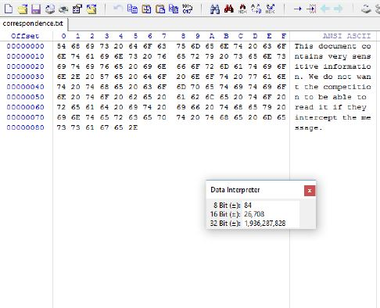
First left shift image

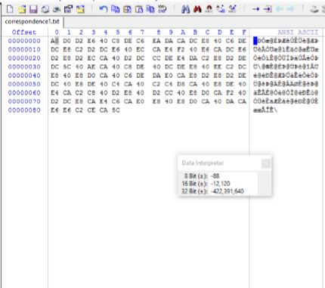
We get back the original message After 7 shifts

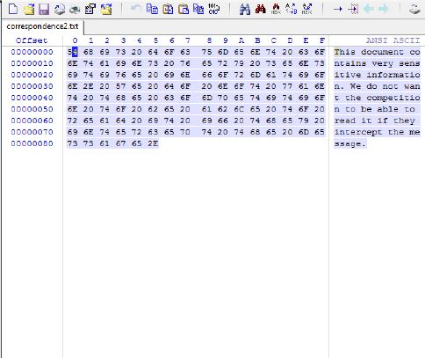
The method we are following here is not reliable for using as an encryption method as we are shifting bits to the left. Any intruder can easily decode the message from this. Not a suitable form of encryption.

